Risk Assessement

**RAM Size: 3X3**

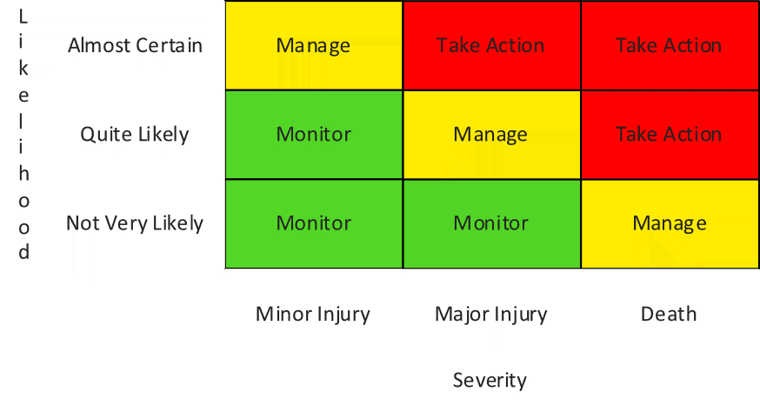

1

1

3

2

3

2

1

RAM Size: 3X3

|  |  |  |  |  |  |  |  |  |  |  |  |  |
| --- | --- | --- | --- | --- | --- | --- | --- | --- | --- | --- | --- | --- |
| Sl. No. | Hazard | Who might be harmed & how might be harmed | Existing Control measure | L | C | R | Additional control measure | L | C | R | Time scale | Responsible person |
| 0. | Height Work | Worker,  Co-worker  Fall from height cause fracture, spinal injury, head injury, death  Falling of material cause hit injury on head | Guard rails provided  Safety belt to be provided | 2 | 2 | 4 | Safety net to be provided  Trained worker to be appointed &  Appoint supervisor | 1 | 1 | 1 | 1 week | Safety officer |
| 1. | Vibration |  |  |  |  |  |  |  |  |  |  |  |
| 2. | Fire |  |  |  |  |  |  |  |  |  |  |  |
| 3. | Electricity |  |  |  |  |  |  |  |  |  |  |  |
| 4. | Excavation |  |  |  |  |  |  |  |  |  |  |  |